Problem 2.28

Design a problem, using Fig. 2.92, to help other students better understand series and parallel circuits.
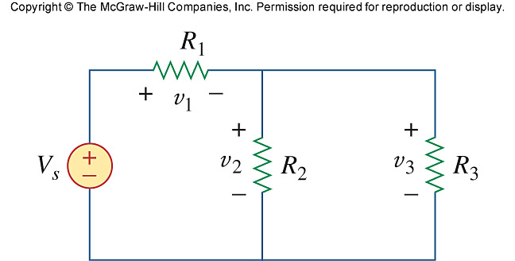

Figure 2.92
For Prob. 2.28.

